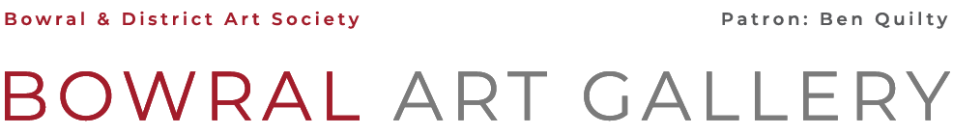


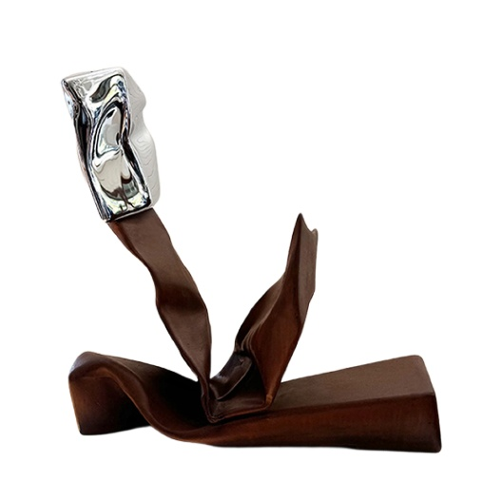
Bowral Art Gallery invites you to enter the

2026 BOWRAL SCULPTURE PRIZE
Sponsored by
ALLMAN JOHNSTON + MHDP ARCHITECTS

1st PRIZE: $5,000
2ND PRIZE: $1,000
BDAS People’s Choice $250
Judge: Ingrid Morely
2025 Winner Gary Christian Sailing with the Sirens

THE EXHIBITION WILL BE OPEN: 9 – 24 May Open daily from 10am to 4pm

OPENING & PRIZE PRESENTATION: Friday 8 May at 6pm

ENTRY FORM & FEE:
To be received by the BDAS office by 4pm Wednesday 22 April
Entries may now be completed on line : www.bdasgallery.com/entry-forms

WORKS TO BE DELIVERED : Wednesday 6 May 10am to 1pm or by prior arrangement.

WORKS TO BE REMOVED: Sunday 24 May from 4.00pm to 5.00pm

ENTRY DETAILS: Name: ...................................................................................................................................................................................
Email Address: ……………………………………………………………………………………………...…………Phone ................................................................
Member [ ] Non Member [ ] Payment Cash [ ] Cheque [ ] Credit Card [ ] Bank Transfer [ ]………………………………..
TAX DECLARATION
I am an hobby artist: YES [ ] NO [ ] If not, please provide your ABN …………………………………………….…………...

WORK 1 …………………………………………………………………………………………………………………………………………………………………………………..……
Please indicate : Indoor display only [ ] Outdoor display only [ ]
Materials used / Type of construction ....................................................................................................................................................
Installation time .....................................Dimensions ...................................................................................... ……….Price....................

WORK 2 …………………………………………………………………………………………………………………………………………………………………………………..……
Please indicate : Indoor display only [ ] Outdoor display only [ ]
Materials used / Type of construction ....................................................................................................................................................
Installation time .....................................Dimensions ...................................................................................... ……….Price....................

In submitting an entry form, I agree to all conditions of entry Signed………………………………………………………………..

CONDITIONS OF ENTRY - PLEASE READ CAREFULLY.
There is a limit of 2 pieces per artist, which must be the original work of the artist and not previously displayed with this society. All works must be for sale. The artist warrants that they are the original author of the work. Furthermore, the work does not, to the best of the artist's knowledge, infringe the copyright or moral rights of any third party

SELECTION / LIABILITY
- Sculptural works will need to be of appropriate construction to ensure they pose no risk to the safety of the public.
- The Judge and Curator will consider all entries and their decision on works accepted will be final.
- The BDAS committee accepts no responsibility for damage to exhibits from any cause. It reserves the right to refuse entry to, or to remove, any exhibit which might be a public danger.

INSTALLATION AND REMOVAL FROM SITE
- Entrants must arrange for delivery and collection of works at the specified times
- Prior delivery to: 1 Short St Bowral, may only occur during BDAS Office Hours (Mon - Fri 9am -4pm)
- Delivery & installation will take place on Wednesday 6 May 10am – 1pm
- All works must have a label attached giving artist's name, title of work, medium & price of work for cataloguing.
- Desired locations for sculptures will be taken into consideration, but not guaranteed. The Curator has the final decision on the placement of works.
- All exhibitors will be responsible for the transport of their work to and from the BDAS grounds. Exhibitors are responsible for all costs associated with manufacture, freight, installation, and insurance of their own works.
- Exhibiting artists will be responsible for the installation and dismantling of their sculptures if special installation requirements are involved. Should any proposed exhibit require special installation or equipment to put it in place or any special fixing, the BDAS office should be consulted in early stages on 4861 4093 or email: office@bdasgallery.com to discuss feasibility of submission & selection.
- All packaging materials must be removed from the gallery on delivery of the works.
- Any work not collected within 30 days of closure of the exhibition may be disposed of at the discretion of the Committee.
Refer to www.bdasgallery.com/entry-forms for more information.

Bowral Art Gallery reserves the right to reject any work which does not comply with all conditions.

SUBMISSION OF ENTRY FORM & FEE
Exhibitors are required to complete the application form and submit this with the appropriate fee, to the BDAS office by 4pm on 22 April, together with a digital image of the piece to be exhibited. Artists will be advised of selection.
Entry fees are non-refundable.

- Entries may now be completed on line : www.bdasgallery.com/entry-forms
- An image may be submitted to create an online sales catalogue. This is optional
- Images are to be of a high resolution, 1 – 3MB and the file named with the artists name and title of the work
- Refer to www.bdasgallery.com/entry-forms for more details of online sales conditions.

Members $25 per work, Non-members $35 per work
Payment of entry fees may be by cash, by credit card, by cheque, made payable to BDAS and posted or emailed to Bowral & District Art Society, PO Box 144, BOWRAL, NSW 2576. There is also a locked box outside the office for entries.
For payment via bank transfer, please ensure your name is noted on the transfer instructions and the date of payment is noted on the entry form. Westpac Bowral BSB 032-716 Account No 160102

COPYRIGHT
- The copyright remains the property of the entrant.
- Artists selected to be exhibited grant to the BDAS a non-exclusive, perpetual, royalty-free copyright licence to reproduce images of their work for the non-commercial purposes of the promotion of the BDAS, of future BDAS exhibitions and art prizes and for the BDAS on-line catalogue (optional) and social media platforms.
- No alterations will be made to the image without the artist's consent.
- The Artist will receive credit and be identified as the owner of the work.

SALES & COMMISSION
- A commission of 30% will be charged on all work sold.
- At the completion of the exhibition, the artist will be remitted the balance of the sale, less a further 1.75% EFTPOS surcharge (*where applicable) within 14 days by bank transfer.
- Refer to www.bdasgallery.com/entry-forms for more details of online sales conditions.

INSURANCE
BDAS will exercise every care with works submitted, but will not be responsible for the loss of, damage to, or breakage or damage caused by any exhibits in its’ custody or for the insurance of exhibits either in transit or on exhibition. Exhibitors may wish to arrange their own insurance.

1 Short St BOWRAL NSW PO BOX 144 BOWRAL 2576 E: office@bdasgallery.com PHONE: 02) 4861 4093
www.bdasgallery.com

